Paired Reading for Parent / Carer and Child
(*Parent / Carer referred to as you / adult)

Timing: 15 minutes max

Paired Reading session stages:

- Your child chooses a book for reading. It can be anything – a comic, a story book, novel, a non-fiction book or a magazine

- Talk together about the book especially the pictures before you begin reading – making predictions about the book.

- Start reading together. When your child is ready, they should make a simple signal to you that they want to read alone.

- Praise your child when they are doing well.

- If your child gets stuck while reading alone, wait for up to 4 seconds and then tells them the correct word.

- If your child makes a mistake, correct the mistake. Your child should repeat the word and then carry on reading. When your child makes a mistake, you and your child read together again.

At the end:
Talk with your child about what they have read, give their opinions & comment on story & characters.
You might like to ask them questions about the text.

Paired Reading Stages

child chooses the book
talk about the book / pictures together - make predictions

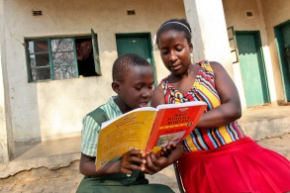 read together

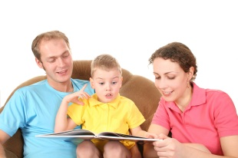

child reads alone

talk about the book – questions / give opinions

